LET’S REVISE SIMPLE PAST TENSE

Simple Past Short Story

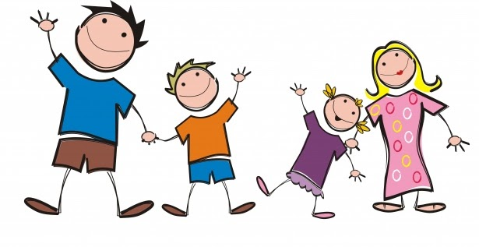

Who are they? What did they do? What happened?

Last Sunday, the Smith’s got up at 9:00. They had breakfast at 9:30. John Smith, the father, washed his car. Mary Smith, the mother, cooked lunch, Tom and Susan, the kids, tidied up their rooms and walked their dog.

In the evening they went to the cinema. They watched a film. The film started at 6:00 and they enjoyed it very much.

After the cinema they went to a park. The kids played with a ball and the parents talked about their kids’ future.

When they returned home they were tired but happy!!!

Task 1

Identify the regular verbs in the Simple Past tense and fill in the chart.

Worksheets

|  |  |
| --- | --- |
| Infinitive | Simple Past |
|  |  |
|  |  |
|  |  |
|  |  |
|  |  |
|  |  |
|  |  |
|  |  |
|  |  |
|  |  |

Task 2

Answer the following questions.

1. What did John do on Saturday morning?

____________________________________________

2. What did Mary do on Saturday morning?

_____________________________________________

3. What did Tom and Susan do on Saturday morning?

_____________________________________________

4. What did the family do on Saturday evening?

________________________________________________

5. Did they enjoy the film?

________________________________________________

SEE YOU!!!!